Analysis Document Gardening System

Tianyi Chen - 4095944

Kevin Vissenberg - 4059506

Bram Wijshake - 3467023

Marco Cardillo - 4076923

Kristiyan Manolov - 3605310

Toma Krastanov - 3774678

2021

Contents

Introduction 2

Use cases 2

Requirements 5

Functional 5

Non - Functional 6

Our solution 7

Context Diagram 7

Hardware 8

Simulated 8

Physical 8

Analysis

# Introduction

The main goal of the project is to automate the process of growing a plant. We are trying to make a machine that can take care of a plant, to give more free time to the customer. Moreover, we want to grant gardening access to people who do not have a backyard or a balcony to plant. These Grow boxes can be easily transported up and down the stairs and around your house.

# Use cases

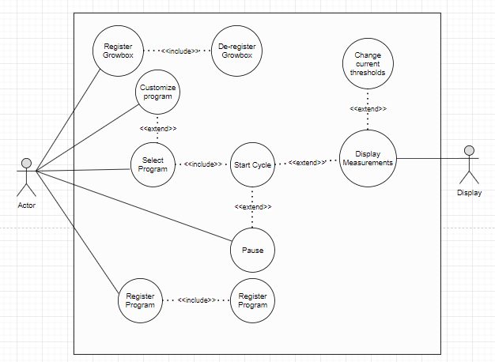

|  |  |
| --- | --- |
| **Use Case ID:001** | **Use Case:** Select the program |
| **Description** | When the user wants to plant a new crop, he can choose between multiple pre-set programs. |
| **Actor**: | The user |

|  |  |
| --- | --- |
| **Use Case ID:002** | **Use Case:** Customize the predefined program |
| **Description** | When the user wants to adjust the settings of the pre-set program, he has access to controlling values such as: The soil PH, Humidity, amount of light needed, and Temperature. |
| **Actor:** | The user |

|  |  |
| --- | --- |
| **Use Case ID:003** | **Use Case:** Create / Remove program |
| **Description** | When the user wants to plant a crop that is not in the pre-set programs he can easily create / remove a new program. |
| **Actor:** | The user |

|  |  |
| --- | --- |
| **Use Case ID:004** | **Use Case:** Register / Remove Grow box from system |
| **Description** | When the user has multiple grow boxes, he should be easily able to connect / disconnect a device. |
| **Actor:** | The user |

|  |  |
| --- | --- |
| **Use Case ID:005** | **Use Case:** Display measurements |
| **Description** | When the user wants to see the current measurements of the grow box, the display shall be able to provide the readings from the sensor at all time. The PH, Temperature, soil moisture level, Light intensity. |
| **Actor:** | Display |

|  |  |
| --- | --- |
| **Use Case ID:006** | **Use Case:** Adjust desired settings |
| **Description** | When the user wants to adjust the current measurements in the grow box, he should be able to control the desired levels of PH, Moisture level, Temperature, and Light intensity. |
| **Actor:** | The User |

|  |  |
| --- | --- |
| **Use Case ID:007** | **Use Case:** Pause/resume program |
| **Description** | When the user wants to remove his plant from the box during an active cycle, he should be able to pause/resume. |
| **Actor:** | The user |

# Requirements

## User Requirements

|  |  |  |
| --- | --- | --- |
| **Requirement ID** | **Description** | **Use Cases** |
| **UR**_001 | A user shall be able to select a pre-defined program for a specific type of crop. | **UC**_001 |
| **UR**_002 | A user shall be able to customize a pre-defined program. | **UC**_002 / **UC**_003 |
| **UR**_003 | A user shall be able to create and save a new program. | **UC**_003 |
| **UR**_004 | A user shall be able to delete one of the users saved programs. | **UC**_003 |
| **UR**_005 | A user shall be able to register a new grow box to the system. | **UC**_004 |
| **UR**_006 | A user shall be able to deregister a grow box from the current system. | **UC**_004 |
| **UR**_007 | A user shall be able to adjust the temperature of the grow box. | **UC**_006 |
| **UR**_008 | A user shall be able to control the light intensity inside the grow box. | **UC**_006 |
| **UR**_009 | A user shall be able to select a PH value for the plant. | **UC**_006 |
| **UR**_010 | A user shall be able to select a threshold to keep the soil moisture at. | **UC**_006 |
| **UR**_011 | A user shall be able to pause the program at any given moment. | **UC**_007 |
| **UR**_012 | A user shall be able to resume the program at any given moment. | **UC**_007 |
| **UR**_013 | A user shall be able to read the temperature of the grow box. | **UC**_005 |
| **UR**_014 | A user shall be able to read the lumens inside the grow box. | **UC**_005 |
| **UR**_015 | A user shall be able to see the PH value of the plant. | **UC**_005 |
| **UR**_016 | A user shall be able to read the soil moisture levels. | **UC**_005 |
| **UR**_017 | A user shall be alerted if there are any leaks in the watering system. | **UC**_005 |
| **UR**_018 | A user shall be ablet to disconnect the device and resume the selected cycle. | **UC_**007 |

## Functional

|  |  |  |
| --- | --- | --- |
| **Functional Requirement ID** | **Description** | **Use Case/UR** |
| **FR**_001 | The system must be able to monitor the soil’s PH value. | **UC**_005 / **UR**_009 |
| **FR**_002 | The system must be able to monitor the soil’s moisture levels. | **UC**_005 / **UR**_010 |
| **FR**_003 | The system must be able to monitor the water levels. | **UC**_016 |
| **FR**_004 | The system must be able to monitor the temperature. | **UC**_013 / **UR**_007 |
| **FR**_005 | The system must be able to monitor the Lumens of the lighting. | **UC**_014 / **UR**_008 |
| **FR**_006 | The system must be able to store unique pre-set program for each different crop. | **UC**_001 / **UR**_001 |
| **FR**_007 | The system must be able to change the settings of the pre-set programs. | **UC**_002-3 / **UR**_002 |
| **FR**_008 | The system must be able to alert the user when the cycle is completed. | **UC**_001-3 / **UR**_001-2 |
| **FR**_009 | The system must be able to maintain the soil’s moisture between desired threshold. | **UC**_005 / **UR**_010 |
| **FR**_010 | The system must be able to decide the light intensity based on desired threshold. | **UC**_005 / **UR**_008 |
| **FR**_011 | The system must be able to modify the PH in the water based on the desired PH levels. | **UC**_005 / **UR**_009 |
| **FR**_012 | The system must be able to maintain the temperature in between a max and minimum threshold. | **UC**_005 / **UR**_007 |
| **FR**_013 | The system must be able to moisturize the soil whenever it is dry | **UC**_005 |
| **FR**_014 | The system must be able to detect leaks on the water valves. | **UC**_005 **/ UR**_017 |
| **FR_**015 | The system must be able to store preset programs in the server. | **UC**_002 / **UR**_002-3 |
| **FR_**016 | The system must be able to read preset programs from the server. | **UC**_002-3 / **UR**_002 |
| **FR_**017 | The system must be able to create new programs and save them on the server. | **UC**_002-3 / **UR**_003 |
| **FR_**018 | The system must be able to remove programs from the server. | **UC**_002-3 / **UR**_004 |
| **FR_**019 | The system must be able to pick up where it left off when the power is lost. | **UC**_007 / **UR**_018 |
| **FR_**020 | The system must have a UI. | **UC**_001-9 |

## Non - Functional

|  |  |  |
| --- | --- | --- |
| **Non-functional Requirement ID** | **Description** | **Use Case/UR** |
| **NR**_001 | The system should have a backup power source. |  |
| **NR**_002 | The system should have a user-friendly UI. |  |
| **NR**_003 | The system should have enough growing space for a large variety of crops. |  |